services.AddSwaggerGen(options =>

{

options.SwaggerDoc("v1", new Swashbuckle.AspNetCore.Swagger.Info

{

Version = "v1",

Title = " API 文档",

Description = "by bj eland"

});

options.AddSecurityDefinition("Bearer", new ApiKeyScheme

{

Description = "请输入带有Bearer的Token",

Name = "Authorization",

In = "header",

Type = "apiKey"

});

options.AddSecurityRequirement(new Dictionary<string, IEnumerable<string>>

{

{ "Bearer", Enumerable.Empty<string>() }

});

});

配置完成后，Swagger页面会有一个弹出层，可以设置Token

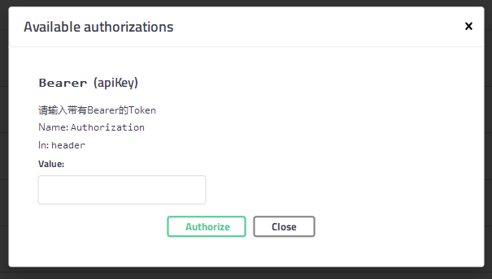

然后我们可以提供一个Api，用于获取Token

